1. Download module file package
2. Create folder app/code/Interactivated/Customerreview
3. Unzip package files to folder app/code/Interactivated/Customerreview
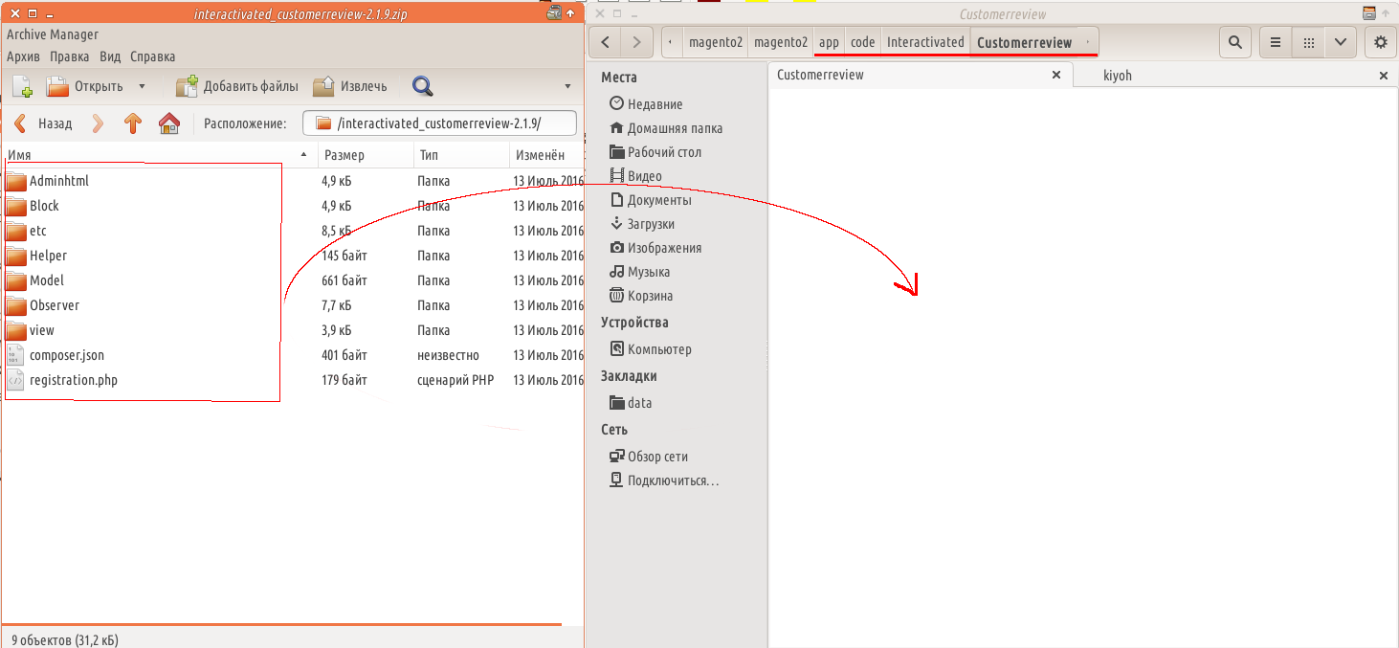
4. Run command
php bin/magento cache:clean

5. Run command
php bin/magento setup:upgrade

6. Run command
php bin/magento setup:static-content:deploy

7. Go to Adminpanel->Stores->Configuration->Kiyoh beoordelingen and configure module based on you preferences
8. Set «Set Microdata functionality» = «yes» and «Company Id» = «Your_company_id_code» if you wish to add microdata rating functionality:


